
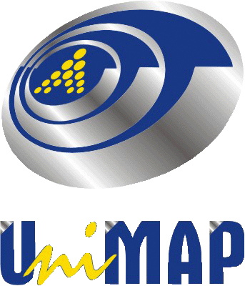
Please complete this form and return it by e-mail, regular mail or fax.
Please note that this is how you will be indicated on your badge and in the list of participants.

Participant’s information

Name:___________________________________________________________________
Title:Prof. Dr. Mr. Ms. Mrs. other:_____________________________________
Designation: Organisation:_________________________________________
Address:_________________________________________________________________
________________________________________________________________________
Postal code:_______________City:_____________________Country:__________________
Telephone:__________________Fax:________________E-mail:______________________

Paper to be presented:
Paper Title_____________________________________________________
_____________________________________________________________
Paper Reference Number: ___

Payment Information

Category: ___
Paper Registration fee: MYR/USD ________

My payment is*:
By bank draft (For local & International participants both):
- Bank Draft No._______________________________
(ii)Issuing Bank Name____________________________
(iii) Amount___________________________________
By WIRE TRANSFER** (Telegraphic Transfer) (For local & International participants both):
- Reference No._______________________________
- Issuing Bank Name___________________________
(iii) Amount____________________

CONFERENCE REGISTRATION FORM
International Conference on Aplications and Design in Mechanical Engineering 2017 – (ICADME 2017)
Bayview Hotel, Georgetown, Penang, Malaysia
Organized by
School of Mechatronic Engineering,
Universiti Malaysia Perlis (UniMAP), Perlis, Malaysia
Conference dates: 21-22, August 2017
I will attend the conference on August 21-22, 2017: YesNo

Local/foreign participants, please submit proof of payment through email or fax before deadline. Currency exchange or bank collection fees are the responsibility of the participant. *The details for the bank transfer or wire transfer are:
Account Name: Universiti Malaysia Perlis
Account no: 09010001234710
Bank Name: Bank Muamalat Malaysia Bhd.
Swift Code: BMMBMYKL
City: KANGAR
State/Country: Perlis/Malaysia
Post Code: 01000
Bank’s Full Address: Bank Muamalat Malaysia Bhd.,Kangar Branch, No. 11& 13, Bangunan PKENPs,Jalan Bukit Lagi, 01000 Kangar,Perlis, Malaysia

Additional Information

If you face any problem regarding registration, please contact the conference secretariat immediately by email given (icadme2017@unimap.edu.my / icadme2017@gmail.com)

Payment Information: Registration form must be accompanied by full payment in order to be processed. Incorrect information i.e. wrong participant name will be considered non-payment and, therefore, registration will not take place. Registration will not be accepted by telephone. Papers without registration fee will not be published in IOP Journal of Physics: Conference Series) Please note that accommodation cost is not included in the conference registration fee.

Refund policy: Under no circumstances registration fee will be refunded. The conference committee maintains no-refund-policy. However, in an event that may cause the participant not being able to attend the conference, a substitute is allowed. However, in such a case inform the matter in writing to the conference secretariat on or before 31 July, 2017.

By signing and sending this registration form, I have taken notice of the cancellation/refund terms mentioned in this form.

Registration Fee

Registration fees include Conference Proceeding, Abstract Book, Lunches and Coffee Break.

Full time Students must enclose a bonafide certificate from Dean/Principal of respective Schools/Departments/Colleges or Universities

Date: _____/_____/______ Signature:_______________________

